Dalrymple Bay Coal Terminal User Group

2015 Draft Amending Access Undertaking

Supplementary Submission to the Queensland Competition Authority – Responses to QCA Staff Questions

26 August 2016

- Background
In response to an initial undertaking notice issued by the Queensland Competition Authority (QCA) on 23 June 2015, on 12 October 2015 DBCT Management Pty Ltd (DBCTM) lodged a draft access undertaking (the 2015 DAU) to replace the current access undertaking.
The QCA invited submissions on the 2015 DAU and, following consideration of submissions received from stakeholders, issued its draft decision on 19 April 2016 (the Draft Decision).
The users of the Dalrymple Bay Coal Terminal (the DBCT User Group), provided a submission on 8 July 2016 in response to the Draft Decision, and have subsequently provided supplementary submissions in relation to debt risk premium issues and estimation of gamma.
On 3 August 2016, the QCA published QCA Staff Questions for Stakeholders (the QCA Questions).
This supplementary submission responds to the QCA Questions.
As it does not restate in their entirety previous submissions the DBCT User Group has made on the issues under consideration in respect of the 2015 DAU, it should be read together with each of the previous submissions made by the DBCT User Group during the 2015 DAU process including:
    - the DBCT User Group Submission dated 24 November 2015;
    - the DBCT User Group Supplementary Submission dated 22 January 2016;
    - the DBCT User Group Submission dated 8 July 2016;
    - the DBCT User Group Submission on debt risk premium dated 21 July 2016; and
    - the DBCT User Group Submission on gamma dated 22 August 2016.

- Differential Pricing
  - Inclusion of additional criteria
The QCA has sought comments from stakeholders on the appropriateness of DBCTM's proposals to include additional criteria in clause 11.13(c) of the 2015 DAU, for the QCA to consider when assessing an expansion pricing application.
The DBCT User Group considers the list of criteria proposed by the QCA in the Draft Decision remains appropriate and opposes the inclusion of the additional criteria now proposed by DBCTM.
The table below provides responses to each of the additional factors proposed by DBCTM in its most recent submission:
Factor proposed by DBCTM | DBCT User Group Position
the possibility that expansion users could switch usage to the pre-expansion infrastructure should excess capacity emerge there subsequently | The DBCT User Group opposes the inclusion of this factor.  No explanation is given in the DBCTM submission as to why this factor is relevant. The DBCT User Group assumes that DBCTM has proposed its inclusion on the basis that the likelihood of 'switching' to contracting capacity in the existing terminal is an argument in favour of socialisation.  However, if there is a high likelihood of an expansion user switching to contracting surplus capacity in the existing terminal following the expiry of the initial term of its User Agreement, that raises clear questions about whether the expansion was a highly inefficient investment that should not have been made. The type of expansion that is not anticipated to be contracted for its useful life is a clear example of the very type of expansion that should not be socialised.  If DBCTM wishes to take the investment risk involved in such an expansion, that is not a risk which users of the existing terminal should be required to assume (or would ever have reasonably anticipated they would have to assume).
the complexity associated with allocating costs of future O&M and NECAP activities between expansion and existing users | The DBCT User Group opposes the inclusion of this factor.  Firstly, DBCTM substantially overstates the complexity involved in this allocation. The QCA has set out in the Draft Decision/Final Decision on the Ringfencing DAAU the principles which it would apply, and a costing manual will (when this issue becomes relevant) be approved which will provide details for how cost allocations will occur. The QCA is highly experienced in making decisions regarding cost allocations, and the principles proposed are based on that experience.  Secondly, this issue would already be captured as part of the existing QCA drafting and is not of sufficient importance to warrant a separate reference. In particular, the DBCT User Group notes the following two factors:  - 11.13(c)(1) – the materiality of the increase in the Existing Terminal's Reference Tariff that would be affected by socialising the Cost Sensitive Expansion; and  - 11.13(c)(3) – the extent to which assets or infrastructure the subject of the Cost Sensitive Expansion will operate wholly or partly, in an integrated way with the Existing Terminal or a stand-alone development.  Those factors will already allow the QCA to assess the complexity of cost allocations (which will arguably be more complex if wholly integrated) and consider any complexity in the context of the materiality of the change in reference tariffs. Given that the QCA would already be empowered to consider this issue, the DBCT User Group considers that specifically including it as a stand-alone factor is unnecessarily prescriptive, and likely to result in undue emphasis being placed on this minor issue.
whether the services that the expansion infrastructure provides are functionally equivalent to the services that the existing infrastructure provides | The DBCT User Group opposes the inclusion of this factor.  Firstly, is not clear why this factor is of any relevance at all to the decision on differential pricing. The services provided by any expansion would be expected to be functionally equivalent to the coal handling services of the existing terminal irrespective of the cost involved. There is, for instance, no reasonable prospect of a different gauge rail connection being constructed at the terminal given any expansion would presumably be designed to be able to be utilised by the widest possible range of Goonyella coal chain users.  Secondly, to the extent that the expansion provides a functionally different service, then it will clearly be captured by the factor proposed by the QCA in relation to the extent of integration in any case (as it is hard to see how the infrastructure would provide a functionally different service unless it was principally or completely stand-alone).
any other factors that the QCA considers relevant | The DBCT User Group considers this inclusion is unnecessary as, based on the QCA's drafting, the factors listed in clause 11.13(c) are those which it is mandatory for the QCA to have regard to.  Under the QCA's drafting, the QCA continues to have the discretion to consider other factors that the QCA considers relevant without the additional wording DBCT is proposing. In that context, an express reference of this type arguably diminishes the importance likely to be given to the mandatory factors that the QCA has already proposed (and which the DBCT User Group supports).  The DBCT User Group is absolutely opposed to the inclusion of this factor if the QCA was to also consider removing the reference to 'exceptional circumstances' (see section 2.4 of this submission below). The combination of these changes would give rise to material uncertainty in relation to how the QCA would determine which other factors were relevant and what weight they should be given.

  - Whether 'incremental up/average down' should be applied against TIC or total access charges
The QCA has sought comments from stakeholders on the appropriateness of DBCTM's proposal that the base assessment of the 'incremental up/average down' approach should be conducted on the impact on total access charges (TAC), rather than the terminal infrastructure charge (TIC).
The DBCT User Group remains strongly in favour of the QCA's approach in the Draft Decision (i.e. basing its assessment of the 'incremental up/average down' on the TIC).
The DBCT User Group favours that position because:
    - there is a much higher degree of certainty regarding how a differentiated expansion will impact on the TIC than operating and maintenance costs, and therefore TAC. It is critical for access seekers (and DBCTM) to understand with as much certainty as possible the likely pricing treatment in relation to an expansion so they can make efficient investment decisions in mines, rail contracts and in the terminal expansion itself. That higher certainty arises from:
      - the capital costs of the expansion being a one-off expenditure the quantum of which is known with a high degree of certainty, whereas the operating and maintenance costs are budgeted forecasts over a long period of time; and
      - the impact on operating and maintenance costs is dependent on numerous variables including DBCTM's approach to future capital budgets, future operating methodology of the operator and the terminal and the impact of economic conditions on the costs of inputs;
    - the operating and maintenance charges attributable to new infrastructure forming part of an expansion will naturally trend upwards over the life of infrastructure, such that basing the decision on the initial impact on TAC may result in socialisation of an expansion that actually increases the TAC in the medium to longer term or measured across the life of the terminal or expansion;
    - assessing the impact on TAC will place great importance on the cost allocation methodology and the DBCT User Group is concerned that will lead to DBCTM being economically incentivised to 'game' the system by seeking inappropriate allocations of operating and maintenance costs in order to increase the prospects of pricing for an expansion being socialised; and
    - to the extent there is a significant operating costs benefit (e.g. in circumstances where a differential expansion would slightly increase the TIC but the TAC would substantially decrease) that would already be a factor taken into account in determining whether that was a special circumstance which would justify socialisation – see clause 11.13(c)(3) of the QCA's drafting.
  - Inclusion of new Schedule
The QCA has sought comments from stakeholders on DBCTM's proposal to include a new schedule to the 2015 DAU (Schedule J) which contains drafting which would be included if the QCA determines that an expansion component is to be differentially priced during the term of the access undertaking.
The DBCT User Group opposes Schedule J being included, at least in the manner proposed by DBCTM.
A review of Schedule J indicates that it does not contain all of the amendments that would be required to implement differential pricing (and yet DBCTM appear to have deleted the other consequential changes from the body of the undertaking as well), such that DBCTM's proposed Schedule J is clearly not appropriate.
Even if Schedule J did contain all the appropriate wording the DBCT User Group cannot see any compelling reason to change the QCA's approach at this late stage in the 2015 DAU process.
The QCA has already considered the appropriate drafting to reflect differential pricing in the body of the undertaking. To the extent there is any concern with that drafting, it should simply be rectified in the body of the 2015 DAU. To do otherwise at this late stage of the undertaking process creates risks of unintended consequences arising from Schedule J not properly reflecting the consequential changes required to implement differential pricing.
  - Removal of reference to 'exceptional circumstances'
The DBCT User Group acknowledges that the QCA did not specifically request comments on all of DBCTM's latest submissions in relation to differential pricing. However, the DBCTM proposal to remove the reference to 'exceptional circumstances' being required to justify departure from 'incremental up/average down' is clearly connected to the other changes raised in QCA Questions. It is also not something on which the DBCT User Group has had a chance to make submissions and is strongly opposed by the DBCT User Group.
As noted in the QCA's Discussion Paper:
    - where long-term access capacity contracts apply, the most important factor in deciding on the pricing of access to a major new tranche of access capacity is likely to be the unit cost of the new tranche compared to the existing capacity (at page 6); and
    - with long term capacity contracting, if average costs are rising substantially with a new tranche of capacity, it will in general be neither fair nor efficient for the higher costs of the new tranche to be added to existing costs and a socialised price then charged. In this case, socialisation of costs clearly implies a subsidy to expanding users where there is no apparent economic efficiency or fairness rationale for doing so (at page 16).
As such, it is clear that changes in pricing should determine the outcome, subject only to the proviso (which the DBCT User Group has always acknowledged) of the potential for exceptional circumstances.
By contrast, the DBCTM approach:
    - relegates the impact of changes in pricing to just one of a number of factors – creating substantial uncertainty for access seekers (and DBCTM) regarding the likely treatment of an expansion, when they will have to make investment decisions in mines and rail contracting based on anticipated pricing treatment; and
    - is inconsistent with the QCA's well-reasoned and settled approach to differential pricing based on what the parties would reasonably be anticipated to have agreed (the reference transaction referred to in the QCA's Discussion Paper).
- Inflation
The QCA’s long-established practice is to determine regulated third party access charges using a nominal modelling framework, meaning that an explicit assessment is required for inflation. For DBCTM, inflation enters the regulatory modelling in several different ways:
    - a forecast of inflation is used to index the regulatory asset base (RAB), with this same “indexation” amount applied as a revenue offset in the derivation of the Annual Revenue Requirement (ARR);
    - a forecast of inflation is used to estimate other (future) cost items, including corporate overheads and the future anticipated cost of terminal remediation; and
    - during the regulatory period, the annual roll-forward of the RAB uses actual (outturn) inflation, which then sets the capital base on which future period return on capital and depreciation amounts are determined.
The QCA’s established practice is to adopt the mid-point of the Reserve Bank of Australia’s (RBA) target range of 2-3% as an estimate for expected annual inflation over the relevant regulatory period. The QCA has applied this methodology for the past decade and a half, and most recently used the same approach to finalise Aurizon Networks’ 2014 access undertaking.
The QCA has sought comments from stakeholders on DBCTM's proposed changes to the treatment of inflation, namely:
    - that expected inflation should be estimated by reference to the margin between indexed and nominal bonds of comparable credit quality/tenor, replacing the current forecast of 2.5%, being the midpoint of the RBA target band for inflation, and
    - that this expected inflation parameter should be used to index the RAB during the regulatory period, instead of actual/outturn inflation.
The DBCT User Group comments on each of these inflation matters are set out below.
  - Change in methodology used to estimate expected inflation
In the Draft Decision, the QCA adopted an expected inflation rate of 2.50% for ARR modelling purposes, based on the midpoint of the RBA’s target inflation band, and consistent with its well established practice.
DBCTM suggests that inflation is expected to be significantly different to the historically applied mid-point and refers to the RBA's Statement of Monetary Policy for May 2016 indicating that inflation is expected to be below the RBA’s target range until at least 2018. DBCTM submits that the previously-applied approach to determining expected inflation is no longer valid and proposes an alternative ‘indexed bond approach’. This alternative approach seeks to empirically estimate market expectations of inflation for the regulatory period.
To consider whether the indexed bond approach is a better predictor of expected inflation than the mid-point of the RBA’s inflation target range, PwC (the DBCT User Group’s adviser) compared actual outturn inflation and expected inflation using the indexed bond method over the two previous five year regulatory periods. Applying DBCTM’s now-proposed method, PwC estimated that expected inflation would have been assessed as 2.43% for the 2005-06 to 2010-11 regulatory period and 2.52% for the 2011-12 to 2015-16 regulatory period.
Figure 1 compares forecasts of expected inflation at the beginning of each of the previous two regulatory periods with actual annual inflation over that time. Looking only at this 10 year period, it is clear that the indexed bond approach is no more reliable an indicator of inflation that the current mid-point approach. In fact, over this decade actual inflation is trending downwards, yet the indexed bond approach suggests that expected inflation was higher in the second five year regulatory period.

Figure 1: Comparison of Actual inflation versus expected inflation methodologies
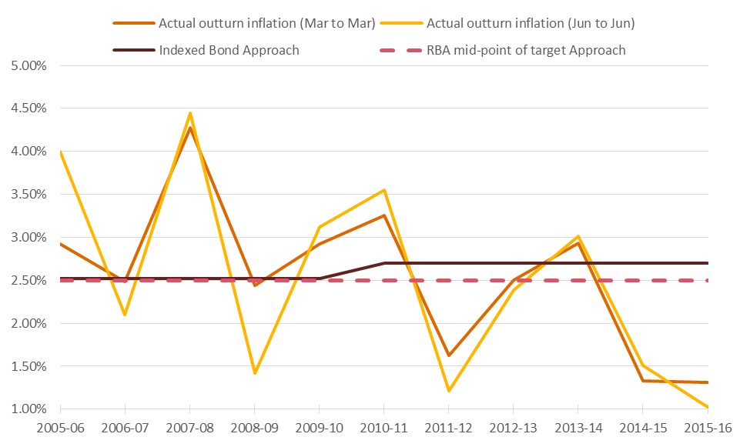
This finding also aligns with Finlay and Wende’s RBA discussion paper, which suggests that the bond indexation method may overstate expected inflation. Finlay and Wende explain that:
‘The inflation yield may not give an accurate reading of inflation expectations, however. This is because investors in nominal bonds will likely demand a premium, over and above their inflation expectations, for bearing inflation risk. That is, the inflation yield will include a premium that will depend positively on the extent of uncertainty about future inflation.’
To assess the extent to which actual inflation falls within the RBA’s target range, Figure 2 below displays annual changes (March to March) in the Australian All Groups consumer price index. Since inflation rate targeting began in 1993, the annualised annual inflation rate has been 2.6%, very close to the 2.5% midpoint of the target band.
Figure 2: Comparison of actual inflation to the RBA target range
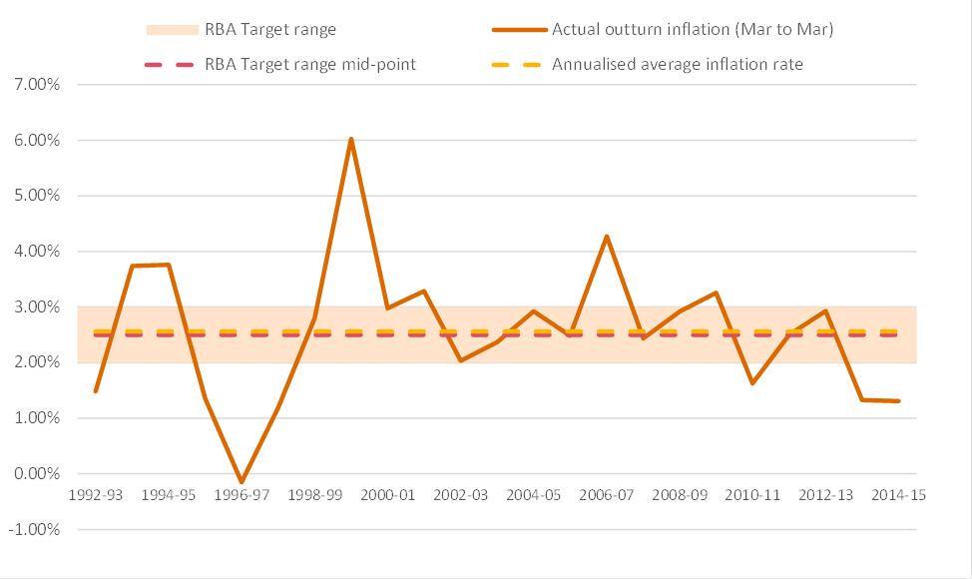
DBCTM’s proposed approach to calculate expected inflation is also inconsistent with the practice of the majority of Australian regulators, as detailed below. All regulators except the ERAWA rely heavily on the RBA’s target inflation range in their calculation of expected inflation.

Regulator | Year | Approach to calculate expected inflation
IPART | 2015 | 10-year geometric average of the one-year RBA inflation forecast and the mid-point of the RBA’s target band of inflation, 2.5%, for the remaining nine years.
ACCC | 2015 | 10-year geometric average of the one-year RBA inflation forecast and the mid-point of the RBA’s target band of inflation, 2.5%, for the remaining nine years.
AER | 2016 | 10-year geometric average of the one-year RBA inflation forecast and the mid-point of the RBA’s target band of inflation, 2.5%, for the remaining nine years.
ESCOSA | 2016 | 10-year geometric average of the one-year RBA inflation forecast and the middle of the RBA’s target band of inflation, 2.5%, for the remaining nine years.
ERAWA | 2013 | Bond indexation method using the Fisher equation and the observed yields of 5-year Commonwealth Government Securities and 5-year indexed Treasury bonds.
QCA | 2016 | The mid-point of the RBA target band of inflation, 2.5%.

The AER considered the calculation of expected inflation in its 2016 final decision for Ausnet Services. In that decision the AER specifically noted that the bond indexation approach can be a misleading proxy for expected inflation unless various biases are identified and removed. The AER identified a number of potential sources of bias, including the effect of bond convexity; inflation risk premia, liquidity premia, and inflation indexation lag on nominal and/or indexed bond yields.
The DBCT User Group acknowledges that the efficacy of any estimation method ought to be reviewed periodically. However, the case for departing from the QCA’s long-established practice of estimating expected inflation is not compelling. The DBCT User Group does not support a change in the way that expected inflation is determined.
  - Adopting expected inflation to determine the opening RAB each year
DBCTM is seeking a change from the QCA’s established practice of rolling forward the RAB each year using actual inflation. DBCTM submits that the QCA’s current approach:
‘… creates a problem if the expected inflation rate used in calculating the inflation deduction in a particular year is not well aligned with the inflation expectation implicit in the nominal WACC. If the deduction expectation exceeds the implicit WACC expectation, DBCTM will be undercompensated for inflation in that year. However, if the deduction expectation is lower than the implicit WACC expectation, DBCTM will be overcompensated.’
Importantly, DBCTM acknowledges the current QCA approach is not systemically biased, in that it could lead to DBCTM over- or under-recovering revenue in any particular year. Where actual inflation is higher than expected inflation, then the regulated business is advantaged by this methodological approach.
As shown in Figure 2, over the past two regulatory periods, there have been years where actual inflation has exceeded the QCA’s estimate of expected inflation, and some years where actual inflation was lower. PwC’s analysis suggests that if DBCTM’s now-preferred approach of using expected inflation for the purposes of rolling forward the RAB had been applied since 2005-06, DBCTM would have recovered in the order of $15 million less in 2015-16 dollars (refer to Figure 3 below), relative to the QCA’s approach of rolling forward the RAB using actual inflation.
Figure 3: Estimated DBCTM Over-recovery during previous regulatory periods
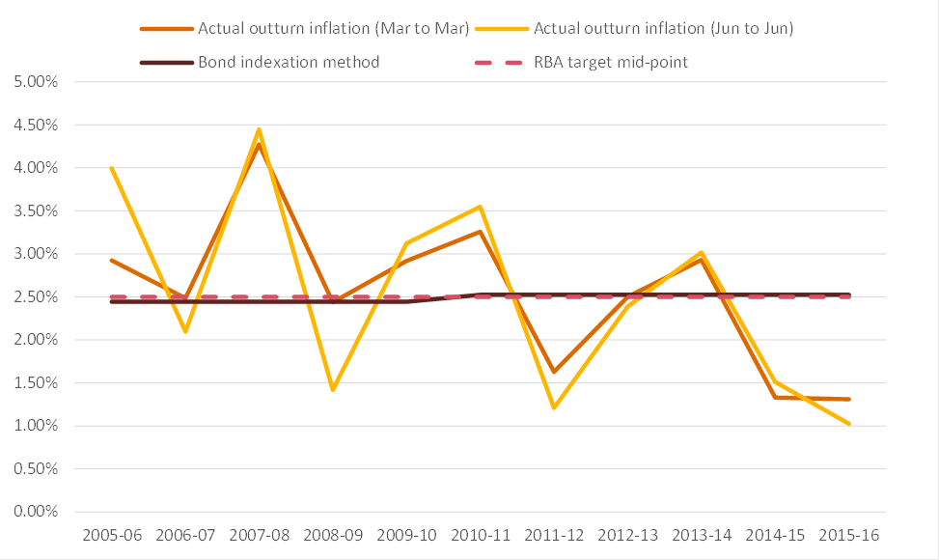
Approx. $15 million

The DBCT User Group is concerned that DBCTM is now proposing a change to this long-established methodology solely because it expects to benefit from it over the coming regulatory period. Such a change would introduce an inconsistency with the QCA’s approach in approving the Aurizon Network 2014 access undertaking, and indeed each of the QCA’s relevant decisions for the past decade and a half.
- Underinvestment in NECAP
The QCA has sought comments from stakeholders on whether, should the QCA be minded to accept DBCTM's proposal on the approval process for non-expansion capital expenditure (NECAP), it should also require the 2015 DAU to be amended to take into account any underinvestment in prudent NECAP when assessing DBCTM's revenue requirements.
As set out in the DBCT User Group's submissions (see section 12.3 of the Submission in response to the Draft Decision in particular), while the 2015 DAU contains protections against over-investment or gold plating, it contains no effective protections against underinvestment in prudent and efficient NECAP. The protections which exist in respect of other QCA regulated infrastructure (such as the Aurizon and Queensland Rail networks) in terms of not accepting some operating and maintenance costs as prudent, do not apply in relation to DBCT. That 'gap' in protection arises due to the different structure for provision of operations and maintenance services and charging for such costs.
The DBCT User Group therefore continues to consider both that:
    - it is appropriate for there to be consequences for failures to make prudent and efficient investment in NECAP; and
    - the most appropriate position is for the 2015 DAU to be amended to require DBCTM to invest in prudent and efficient NECAP as set out in its previous submissions.
However, in the absence of the QCA requiring that, the DBCT User Group continues to consider the next most appropriate response is that set out at the end of section 12.3 of the DBCT User Group Submission in response to the Draft Decision, including that the QCA:
'require the undertaking be amended to clearly provide mechanisms to allow the QCA to implement the potential response referred to on page 209 of the Draft Decision, namely: 'the QCA considers that any over-expenditure of operating expenditure which could have been avoided by a failure by DBCTM to undertake appropriate and prudent investment in NECAP may be grounds for a reduction in DBCTM's recoverable revenue' – there is no evident mechanism provided in the QCA's proposed drafting for that to occur and if this is how the QCA intends to control this issue that should be formalised in Schedule C'
As noted in those comments, the DBCT User Group cannot see how the QCA has the discretion to adjust DBCTM's recoverable revenue in that way under the 2015 DAU terms (as currently proposed).
It is appropriate for the QCA to:
    - ensure it has the very clear power to make an adjustment of the type referred to in the Draft Decision; and
    - provide a clear signal to DBCTM that there is real potential for that occurring if there is ongoing underinvestment in prudent and efficient NECAP.
That is clearly the outcome which is consistent with the object of Part 5 of the QCA Act (which the QCA must have regard to in section 138(2) QCA Act) – to promote the economically efficient operation of, use of and investment in, significant infrastructure.
The QCA would, of course, have a discretion as to whether it exercised the right to adjust DBCTM's recoverable revenue at the relevant time. Consequently, the DBCT User Group's proposal is simply seeking for the ability for such adjustments to be made where appropriate, not creating risks of inappropriate adjustments.
- Competition between ports
The QCA has sought comments from stakeholders on whether the competitive drivers relating to expansion tonnage are likely to differ from those relating to existing tonnage (seemingly in response to submissions made by DBCTM in respect of Abbot Point Coal Terminal (APCT)).
Before turning to expansion tonnage, it is worth noting that there is currently surplus capacity at the Dalrymple Bay Coal Terminal, for which APCT is clearly not competitive. In the current regulatory period (where an expansion is not imminently anticipated), that is the most relevant data for assessing the extent of competition the QCA needs to consider capacity in the existing terminal at DBCT with expansion capacity at APCT.
The DBCT User Group also notes that both the Australian Competition and Consumer Commission and the QCA have recently found that the APCT does not provide effective competition to DBCT. No evidence has been provided subsequent to those findings to suggest that the extent of competition has more recently changed.
In addition, to the extent that there ceases to be surplus capacity available at DBCT (such that an expansion would be required), it is critical to understand that:
    - there is not currently surplus capacity at the existing APCT, such that any assessment of whether competition exists for expansion tonnage needs to be a comparison of an APCT expansion (which is anticipated to be a new, high cost stand-alone terminal) against a DBCT expansion;
    - APCT remains uncompetitive in any such comparison due to each of the issues mentioned in previous submissions, namely:
      - terminal cost differences;
      - insufficient terminal capacity at alternative terminals;
      - multi-cargo and coal blending requirements at DBCT that are not available at other terminals (particularly for metallurgical coal);
      - significant additional above and below rail costs;
      - insufficient below rail capacity (in the absence of costly expansions);
      - capital investment required in mine-specific rail infrastructure (for some mines to even be physically capable of railing coal to another terminal);
      - rail network differences providing some barriers to a rail haulage provider switching the location of services (i.e. using electric locomotives from the Goonyella system for a diesel only part of the network such as the Newlands system to Abbot Point); and
      - restraints on substitution arising from long term take or pay commitments for above and below rail services.
The DBCT User Group also rejects the suggestion in DBCTM's recent submissions that the contracting of APCT capacity referred to in DBCTM's recent submission is evidence of competition between DBCT and APCT. It is not evidence of that because:
    - DBCTM had indicated to users that it was not willing to expand DBCT to meet the demand for terminal capacity (with Brookfield instead proposing to meet that demand from the development of the unregulated Dudgeon Point Coal Terminal project) – such that it cannot be said that users chose APCT over DBCT;
    - the ability to utilise any terminal to meet the demand was dependent on the ability to obtain below rail access, and at the relevant time access seekers faced the combination of:
      - system capacity being below capacity at DBCT and greater supply chain capacity losses;
      - Aurizon Network wanting to invest in the Goonyella to Abbot Point Expansion,
      - Aurizon Network's access services being regulated in a manner which did not provide for an effective user funding regime for access seekers wanting a different rail access solution to DBCT; and
    - the aggregate demand which existed was of such a size that it could justify the development of a substantial expansion of APCT, whereas that appears less likely to be the case during the next regulatory period.
Finally, the DBCT User Group notes DBCTM's own proposed Master Plan indicates that "A further expansion of DBCT is a cost competitive solution for northern and central Bowen Basin mines, notwithstanding the spare capacity reportedly available at Wiggins Island and Abbot Point. DBCT’s cost advantage exists due to its proximity and relatively lower total freight cost." (at page 47).
- Operator
The QCA has sought comments from stakeholders on the appropriateness of DBCTM's proposals to:
    - delete proposed drafting in the draft decision regarding the role and identity of the Operator, regulatory procedurals and approval processes DBCTM must comply with prior to changing the Operator and minimum terms to be included in the operations and maintenance contract and Terminal Regulations applying to a new Operator; and
    - include new regulatory procedures to be followed by DBCTM within 28 days of DBCTM changing the identity of the Operator.
Consistent with the DBCT User Group's previous submissions, the DBCT User Group supports the QCA's current drafting regarding each of the matters set out above.
The 2015 DAU is premised on the basis of there being an independent user-owned operator which both owes contractual obligations to DBCTM regarding the standard of operations and maintenance and has a natural alignment with the users of the terminal.
That premise is clearly evident in:
    - the pass-through nature of how operating and maintenance costs are charged to users (without additional checks in relation to prudency and efficiency);
    - the role the operator is given in relation to proposing changes to terminal regulations;
    - the role the operator has in relation to scheduling arrangements in the Dalrymple Bay Coal Chain;
    - the responsibility for proposing operating and maintenance cost allocations between terminal components; and
    - the streamlined approval process for capital expenditure which applies where the capital expenditure is recommended by the operator.
Given that the QCA is proposing that the access undertaking will continue following a change in operator, it is critical for the continuing effective operation of the access undertaking that the operator remains:
    - independent and user-owned;
    - subject to substantially the same contractual obligations to DBCTM,
and that the QCA has had an opportunity to consider the appropriate changes required to reflect any differences in the new operator or operational arrangements.
The DBCT User Group reiterates its comments from its recent 8 July 2016 submission that:
    - only majority ownership by users allows users to have meaningful control of the Operator, including the approval of operational plans and annual operating budgets;
    - user-ownership maximises alignment of the day-to-day operation of the terminal with the day-to-day operation of the Dalrymple Bay Coal Chain, which optimises the efficiency of the terminal;
    - user-ownership provides a higher degree of transparency and accountability to access holders in the operation of the terminal (and issues like changes to Terminal Regulations and cost allocations between components of the terminal which the operator has involvement in); and
    - the ability of DBCTM to operate the Terminal in a way which will unfairly advantage any given party is minimised where it does not have majority or equal control of the Terminal.
In addition, the DBCT User Group considers that DBCTM's proposal to include regulatory procedures to be followed post-change of operator do not provide same level of protection as QCA approvals being required prior to change. To state the obvious, it is better to prevent adverse impacts arising through appropriate QCA consideration prior to the change, than to create risks of adverse impacts in the interim period between the change and the finalisation of the post-change regulatory processes.
The DBCT User Group also finds it difficult to understand how any of the above disadvantages DBCTM. An independent user-owned operator, operating the terminal under substantially the same terms as the current operations and maintenance contract, has been in place throughout the period since privatisation of the terminal. The proposal is therefore merely to continue the status quo which existed at the time Brookfield made its investment in the terminal.
For completeness, the DBCT User Group notes that these concerns exist completely independent of the previously proposed transaction in respect of acquisition of the Asciano business. Consequently, their deletion cannot be justified by that transaction no longer proceeding in the manner initially envisaged at the time of the QCA assessing the Ringfencing draft amending access undertaking.
- Master Plan
The QCA has sought comments from stakeholders on DBCTM's proposed Master Plan as included in its most recent submission.
DBCTM appreciates that the Master Plan is a forward looking document prepared by DBCTM. It is not an independent assessment of prudency of the expansion options which are outlined. The DBCT User Group notes that it is not in a position to comment on the prudency or otherwise of the costs shown for the various expansions in the draft Master Plan or the expansions themselves, and those issues need to be assessed closer to the timing of investment.
However, in order to be of most use, the Master Plan should be a balanced document in relation to its assessment of future projects in the context of anticipated levels of contracting and potential expansion scenarios. The DBCT User Group consider that section 2.4 seeks to emphasise DBCTM's perceived risks relating to the existing contract profile, while not comparing that to the level of comfort that can be derived from the coal market supply and demand analysis (see section 4.1-4.4) and the level of existing access requests (see section 4.5). In particular, the DBCT User Group continues to dispute some of the comments made about the coal market for the same reasons given in previous submissions.

DBCTM has not published calculations, nor has it indicated the sampling period used for each historical estimate. Therefore, PwC has estimated expected annual inflation by applying the indexed bond method and arrived at different rates for each historical regulatory period (calculated as the average interpolated yield of Commonwealth Government Securities maturing 5 years from each day in the corresponding 20 day averaging period). However, note that PwC’s estimate for expected inflation for the 2015 DAU reconciles to 1.45% as calculated by DBCTM.
Richard Finlay and Sebastian Wende, Estimating inflation with a limited number of indexed bonds, Research Discussion Paper RDP 2011-01, Reserve Bank of Australia
IPART, 2015, New approach to forecasting the WACC inflation adjustment, p.1
ACCC, 2015, Public Inquiry into final access determinations for fixed line services, p.73
AER, 2016, Draft decision AusNet Services transmission determination 2017-18 to 2021-22 Attachment 3 – Rate of Return, p.130
ESCOSA, 2016, SA Water Regulatory Determination 2016 Final determination, p.126
ERAWA, 2013, Explanatory Statement for the Rate of Return Guidelines, p. 224
QCA, 2016, DBCT Management’s 2015 draft access undertaking, p. 166 (see Table 30)
AER, 2016, Draft decision AusNet Services transmission determination 2017-18 to 2021-22 Attachment 3 – Rate of Return, p.130

